JAVA PROJECT

Sweta sahu

16csu382

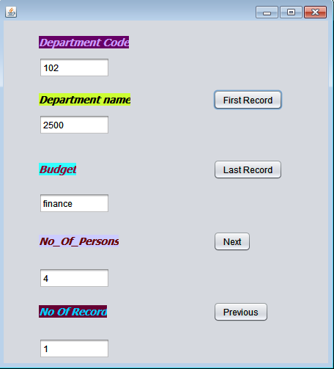

**FIRST RECORD:-**

try{Class.forName("java.sql.DriverManager");

Connection

con=(Connection)DriverManager.getConnection("jdbc:mysql://localhost:3306/sweta","root","1234");

Statement stmt=(Statement)con.createStatement();

String q="Select * from department";

ResultSet rs=stmt.executeQuery(q);

rs.first();

DepCode.setText(rs.getString(1));

DepName.setText(rs.getString(2));

Budget.setText(rs.getString(3));

No_Of_Persons.setText(rs.getString(4));

RecordNo.setText("1");

} catch(Exception e)

{JOptionPane.showMessageDialog(null,e.getMessage());}

**LAST RECORD:-**

int n = 0;

try{Class.forName("java.sql.DriverManager");

Connection

con=(Connection)DriverManager.getConnection("jdbc:mysql://localhost:3306/sweta","root","1234");

Statement stmt=(Statement)con.createStatement();

String q="select * from department";

ResultSet rs=stmt.executeQuery(q);

rs.last();

int a=rs.getRow();

int r=Integer.parseInt(RecordNo.getText());

if(n==r)

{rs.absolute(r+1);}

DepCode.setText(rs.getString(1));

DepName.setText(rs.getString(2));

Budget.setText(rs.getString(3));

No_Of_Persons.setText(rs.getString(4));

RecordNo.setText(r+"");

}

catch(Exception e)

{JOptionPane.showMessageDialog(null,e.getMessage());

}

**NEXT:-**

try{Class.forName("java.sql.DriverManager");

Connection

con=(Connection)DriverManager.getConnection("jdbc:mysql://localhost:3306/sweta","root","1234");

Statement stmt=(Statement)con.createStatement();

String q="select * from department";

ResultSet rs=stmt.executeQuery(q);

int n=Integer.parseInt(RecordNo.getText());

if(n==1)

rs.last();

else{rs.absolute(n-1);}

DepCode.setText(rs.getString(1));

DepName.setText(rs.getString(2));

Budget.setText(rs.getString(3));

No_Of_Persons.setText(rs.getString(4));

RecordNo.setText(n+"");}

catch(Exception e)

{JOptionPane.showMessageDialog(null,e.getMessage());}

**PREVIOUS:-**

try{Class.forName("java.sql.DriverManager");

Connection con=(Connection)DriverManager.getConnection("jdbc:mysql://localhost:3306/sweta","root","1234");

Statement stmt=(Statement)con.createStatement();

String q="Select * from Department;";

ResultSet rs=stmt.executeQuery(q);

rs.last();

int n=Integer.parseInt(RecordNo.getText());

if(n==1)

{rs.last();}

else

{rs.absolute(n-1);}

DepCode.setText(rs.getString(1));

DepName.setText(rs.getString(2));

Budget.setText(rs.getString(3));

No_Of_Persons.setText(rs.getString(4));

RecordNo.setText(n+"");}

catch(Exception e)

{JOptionPane.showMessageDialog(null,e.getMessage());}